**Comprehensive Report on Formula 1 Data Management and Visualization Project**

**Introduction**

The Formula 1 Data Management and Visualization Project is a sophisticated assembly of Python scripts and a Jupyter Notebook designed to handle, analyze, and visualize extensive Formula 1 data. This report aims to provide an in-depth analysis of each component, exploring their functionalities, interactions, and the overarching purpose they serve in the realm of data management and sports analytics.

**Section 1: F1Database.py - The Data Steward**

**Overview and Purpose:** F1Database.py forms the foundation of the project, tasked with establishing and managing the database that houses all Formula 1 data.

**Technical Details:**

**SQLite Database:** Utilizes SQLite, a lightweight, file-based database system, ideal for projects not requiring the full-scale power of a server-based database system.

**Data Schema and Table Creation:** Employs SQL commands to create tables, each representing a different aspect of F1 data like circuits, race results, constructors, etc.

**CSV Data Integration:** Incorporates functions to read and load data from CSV files into the respective tables, ensuring that the data is not only stored but also organized effectively.

**Implications and Use Cases:**

**Data Integrity and Retrieval:** By managing a well-structured database, F1Database.py ensures data integrity and efficient retrieval, which is crucial for any subsequent data querying or analysis.

**Scalability and Maintenance:** Its design allows for scalability, accommodating additional data over time, such as new race seasons or updated driver statistics.

Data Security and Accessibility: Ensures that data is securely stored and easily accessible for authorized users, supporting various analytical and operational needs.

**Section 2: F1DataQuery.py - The Data Explorer**

**Overview and Purpose:** F1DataQuery.py acts as the interrogator of the database, extracting and collating specific data for analysis.

**Technical Details:**

**SQL Query Execution:** Leverages SQL queries to extract data, tailored to answer specific questions about races, drivers, constructors, and more.

**Data Aggregation and Processing:** Processes and aggregates data to provide meaningful insights, such as performance trends, historical comparisons, and statistical summaries.

**Pandas Integration:** Utilizes the Pandas library for data manipulation, enabling complex operations like data filtering, grouping, and statistical analysis.

**Implications and Use Cases:**

**Strategic Insights:** Assists teams and analysts in deriving strategic insights, such as identifying winning patterns or evaluating competitor strategies.

**Historical Data Analysis:** Facilitates historical comparisons, essential for understanding the evolution of teams, drivers, and the sport itself.

**Custom Reporting:** Supports custom report generation, catering to diverse analytical needs, from media coverage to fan engagement strategies.

**Section 3: F1DataVisualization.py - The Data Artist**

**Overview and Purpose:** `F1DataVisualization.py’ is dedicated to transforming raw data into compelling visual narratives.

**Technical Details:**

**Graphical Representations:** Creates various types of charts and graphs, including pie charts for distribution analysis, line charts for trend visualization, bar charts for comparative analysis, and scatter plots for pattern identification.

**Matplotlib Usage:** Employs Matplotlib, a versatile plotting library in Python, allowing for customizable and interactive visualizations.

**Data Storytelling:** Focuses on data storytelling, presenting complex data in an accessible and engaging manner for a diverse audience.

**Implications and Use Cases:**

**Enhanced Data Comprehension:** Makes complex data sets understandable at a glance, critical for quick decision-making and strategy development.

**Fan Engagement and Media:** Provides visually appealing content for fan engagement on digital platforms and media publications.

**Performance Review Meetings:** Useful in team meetings and performance reviews, where visual data aids in discussing strategies and outcomes.

**Section 4: Main.ipynb - The Central Hub**

**Overview and Purpose:** `Main.ipynb’ acts as the interactive interface, orchestrating the functionalities of the other Python scripts.

**Technical Details:**

**Jupyter Notebook Interface**: Offers a user-friendly environment where code, visualizations, and documentation coexist, allowing for an interactive data exploration experience.

**End-to-End Workflow:** Demonstrates an end-to-end workflow, from data loading and processing to querying and visualization.

Interactive Analysis and Prototyping: Ideal for exploratory data analysis, prototyping data models, and experimenting with different visualization techniques.

**Implications and Use Cases:**

**Research and Development:** Useful in R&D settings where iterative experimentation with data is required.

**Educational Tool:** Serves as an educational tool for teaching data science concepts in the context of sports analytics.

**Reporting and Presentation:** Facilitates the creation of comprehensive reports and presentations, integrating code, outputs, and narrative in a single document.

**Section 5: Potential Applications and Future Extensions**

**Cross-functional Analysis:** Integrating data from various aspects of F1, such as team budgets, sponsorships, and social media engagement, to gain a holistic view of the sport’s ecosystem.

**Predictive** **Analytics:** Implementing machine learning models to predict race outcomes, driver performances, and even financial implications for teams and sponsors.

**Real**-**time** **Data** **Processing**: Expanding the system to handle real-time data for live insights during races, enhancing the experience for teams and fans alike.

**Global** **Fan** **Engagement**: Developing an interactive platform for fans worldwide, offering personalized insights, historical data exploration, and engaging visual content.

**Conclusion:**

The Formula 1 Data Management and Visualization Project represents a comprehensive approach to sports data analytics. Each component, from data storage and querying to visualization and interaction, plays a critical role in transforming raw data into actionable insights. This project not only serves as a powerful tool for teams and analysts but also opens up possibilities for fan engagement and educational uses. With potential extensions into predictive analytics and real-time data processing, the project holds promising prospects for the future of sports analytics and fan interaction in the world of Formula 1 racing.

**Output:**

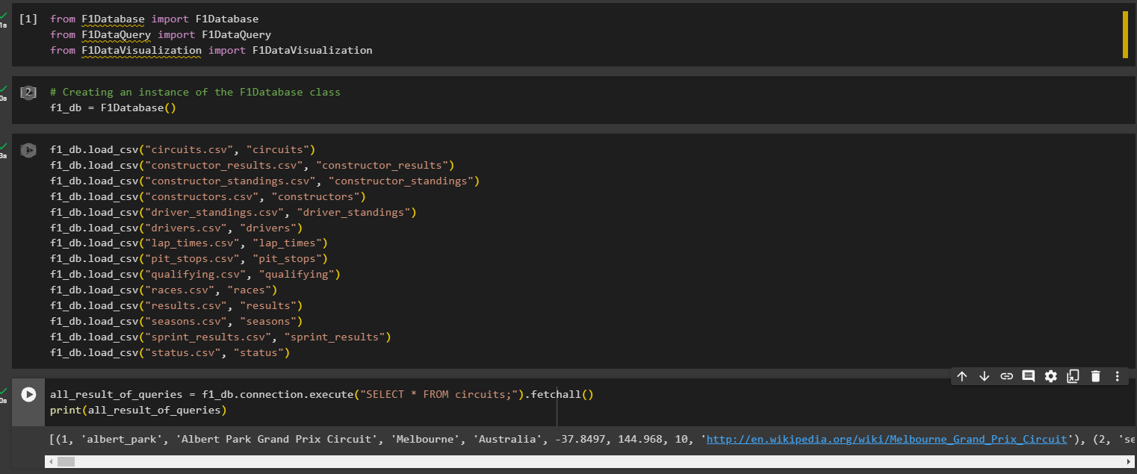

After running these 3 cells it will create a database for it in which it will save all the csv’s data



**Part2:**

1. This will tell the num of circuit .

1. This will tell the races per season

1. This will tell the constructor per nationality

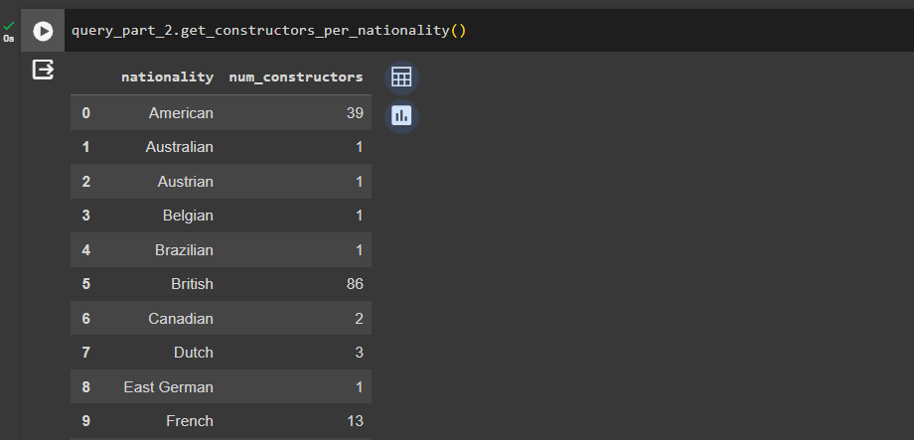

1. This will tell the constructor points.

1. This will tell the constructor points.

**Part3:**

1. Visualization for distribution of country

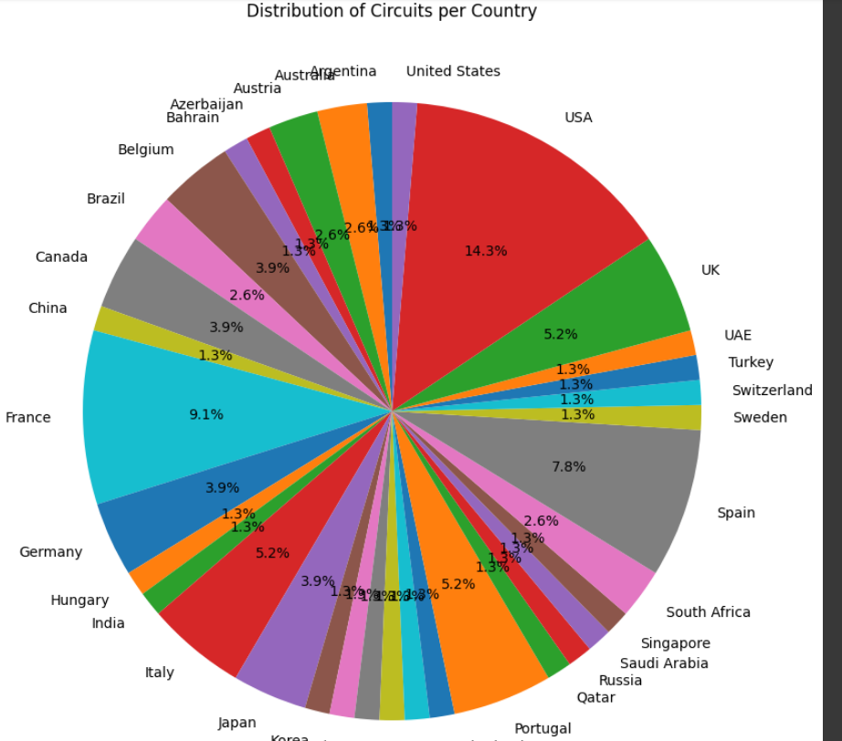

1. Visualization for races per season

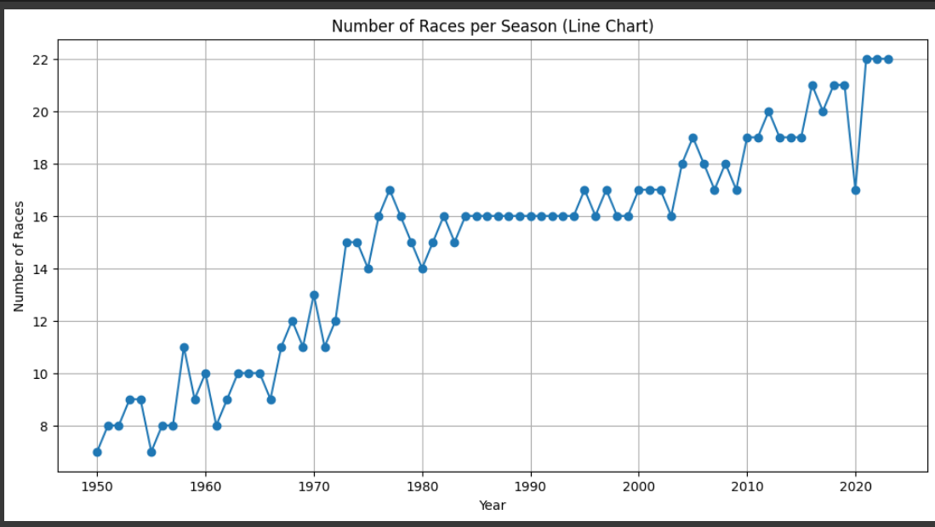

1. Visualization for constructor per nationality

1. Visualization for constructor points

1. Visualization for participation per constructor

